**Name:- Divyang Bagla**

**ERP ID:- 1032180739**

**Batch A2**

**Roll No. :- PC33**

**Lab Assignment No. 4**

**Aim:-** 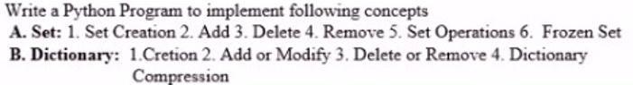

**Theory:-**

**Sets**

**Definition:** Sets are used to store multiple items in a single variable.

Set is one of 4 built-in data types in Python used to store collections of data, the other 3 are List, Tuple, and Dictionary, all with different qualities and usage.

A set is a collection which is both unordered and unindexed.

Sets are written with curly brackets {}.

Set Features:

1. Unordered
2. Unindexed
3. Mutable
4. Duplicates Allowed

**Dictionary**

**Definition:** Dictionary in Python is an ordered collection of data values, used to store data values like a map, which, unlike other Data Types that hold only a single value as an element, Dictionary holds key:value pair.

Key-value is provided in the dictionary to make it more optimized.

Dictonary is written with curly brackets {}.

Dictionary Features:

1. Dictionaries are unordered. A dictionary contains key-value pairs but does not possess an order for the pairs.
2. Keys are unique. Dictionary keys must be unique.
3. Keys must be immutable.

**Lab Assignment 4 Code**

